Planning Logic
Incident Lifecycle Automation in ServiceNow
Project: Automated Incident Management with Knowledge and Change Management integration

1. Purpose
Incident Lifecycle Automation in ServiceNow is the process of managing an IT incident from its creation to closure using automated workflows, Business Rules, and Flow Designer. This document explains the logic behind the plan: what is automated, in what order, why each decision was made, and how Knowledge Management and Change Management plug into the lifecycle to resolve issues faster and reduce recurring incidents.

2. Planning Principles
- Automate the repeatable, keep humans on the judgement. Routing, notifications, SLA tracking and validation are automated; diagnosis and approval stay with people.
- Declarative first. Use Flow Designer and platform configuration before scripting; use Business Rules only where record-level enforcement is needed.
- Every incident leaves a trace. State changes, assignments and resolution details are captured so reporting and problem analysis are reliable.
- Close the loop. Each resolved incident should feed a Knowledge article or a Problem/Change record where it applies.

3. Incident Lifecycle Logic
The lifecycle follows the standard ServiceNow incident states. The table shows the trigger, automation, and exit condition for each stage.
Stage | Trigger | Automation | Exit condition
New | Incident created (portal, email, phone, integration) | Auto-populate fields, calculate priority from impact and urgency, set the SLA, notify caller | Mandatory fields complete
In Progress | Assigned to a group or individual | Assignment rules route by category and subcategory; assignee notified; Knowledge suggestions shown | Assignee starts work
On Hold | Awaiting caller, vendor or change | Require hold reason; pause SLA; reminder notifications | Hold reason cleared
Resolved | Fix applied | Require resolution code and notes; offer to create a Knowledge article; notify caller | Caller confirms or auto-close timer expires
Closed | Confirmation or auto-close after set days | Lock the record; stop SLA; update metrics | None (terminal)
Canceled | Duplicate or raised in error | Require reason; link to parent where applicable | None (terminal)

4. Automation Logic

4.1 Business Rules
Business Rules enforce data integrity at the record level. Planned rules:
- Before insert/update: calculate priority from the impact and urgency matrix.
- Before update: block moving to Resolved without a resolution code and notes.
- Before update: block On Hold without a hold reason.
- After insert: detect likely duplicates by matching caller, configuration item and short description.

4.2 Flow Designer
Flow Designer handles orchestration across steps and teams:
- Trigger: Incident created.
- Look up assignment group from category, subcategory and configuration item; set the group.
- Send acknowledgement to the caller and a notification to the group.
- Branch on priority: P1 and P2 trigger escalation notifications and a manager alert.
- Wait for state change; on Resolved, start the auto-close timer and send a confirmation request.
- On SLA warning (e.g., 75% elapsed), notify the assignee and group manager; on breach, escalate.
- On Closed, update reporting fields and trigger the Knowledge capture prompt if none was linked.

4.3 Notifications and SLAs
- Notifications: creation, assignment, state change, resolution, and SLA warning or breach.
- SLA definitions by priority for response and resolution, with pause conditions for On Hold.

5. Knowledge Management Integration
Goal: resolve incidents faster and avoid repeating the same diagnosis.
- Before work: when an incident is opened, relevant Knowledge articles are suggested based on category and short description, so the agent (or caller on the portal) can self-resolve.
- During work: the agent can attach an article to the incident, which records that the article was used.
- After work: on resolution, if no article exists for the fix, the agent is prompted to create one from the incident (a Knowledge candidate), which goes through review and publishing.
- Measure: track article usage, incidents resolved with an article attached, and incidents deflected through the portal.

6. Change Management Integration
Goal: tie fixes that need a controlled change back to the incident, and learn from incident patterns.
- Incident caused by a change: link the originating Change Request to the incident so the impact of changes is visible.
- Incident requires a change to fix: raise a Change Request from the incident; the incident goes On Hold with the change as the hold reason until the change is implemented.
- Recurring incidents: when similar incidents repeat for the same configuration item or category, create a Problem record; the permanent fix goes through Change Management.
- Closure: when the linked change closes, the incident hold clears and the caller is asked to confirm the fix.

7. Roles and Responsibilities
Role | Responsibility
Caller / End user | Reports the incident, answers information requests, confirms resolution
Service Desk agent | Triage, categorisation, first-line resolution, Knowledge use
Resolver group | Diagnosis and fix; raises Change Requests when needed
Incident manager | Escalations, SLA oversight, major incident coordination
Knowledge manager | Reviews and publishes Knowledge articles
Change manager | Approves and schedules changes linked to incidents
ServiceNow developer | Builds and maintains flows, rules, notifications and reports

8. Delivery Sequence
- Requirements and lifecycle design (states, fields, priority matrix, assignment rules).
- Core configuration: forms, fields, categories, assignment groups, SLAs.
- Business Rules for validation and priority calculation.
- Flow Designer flows for routing, notification, escalation and auto-close.
- Knowledge Management integration.
- Change Management integration and Problem linkage.
- Testing (unit, end-to-end lifecycle, negative cases), then user acceptance.
- Deployment via update set, documentation, and handover.

9. Decision Rules
Situation | Decision
Logic can be set with configuration | Use Flow Designer or platform settings, not scripts
Rule must apply however the record is edited (UI, API, import) | Use a Business Rule
Priority is P1 or P2 | Immediate escalation and manager notification
Fix needs a production change | Raise a Change Request; set incident On Hold
Same issue seen repeatedly | Create a Problem record
Resolution has no matching article | Prompt to create a Knowledge article

10. Success Measures
- Mean time to resolve (MTTR) and SLA compliance rate.
- Percentage of incidents routed correctly on first assignment.
- Percentage of resolved incidents with a Knowledge article attached.
- Number of recurring incidents (Problem records opened) over time.
- Manual touches per incident, compared with the baseline.

Planning Workflow Overview
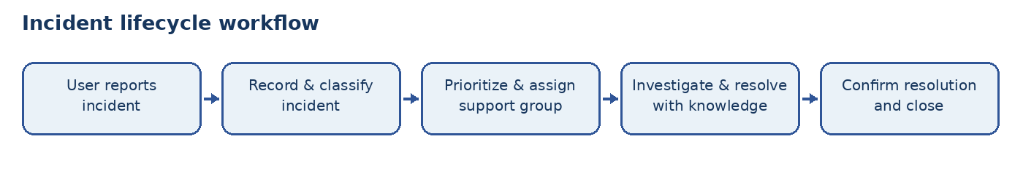

Process Diagram
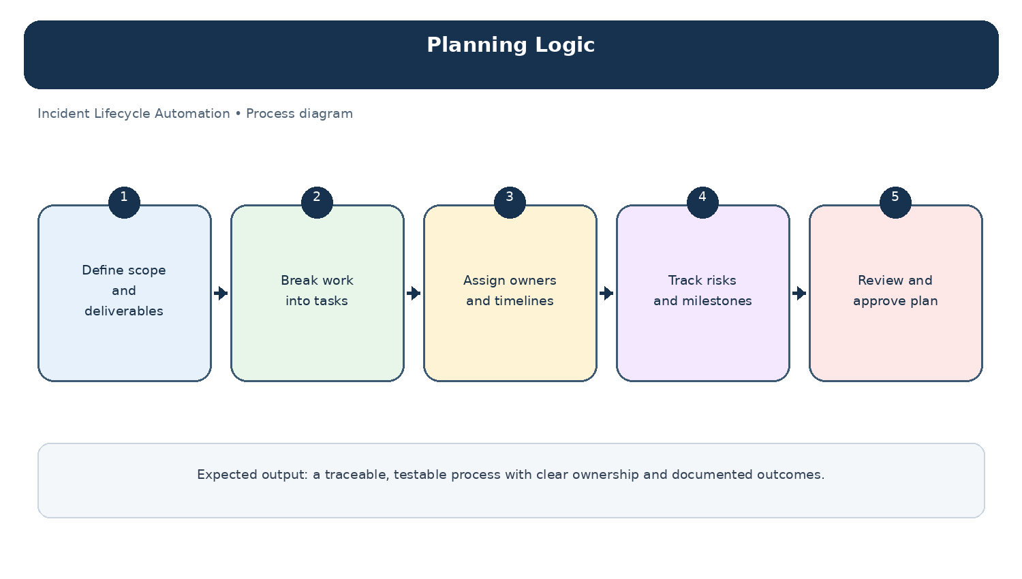
Diagram: Planning Logic — project-specific process overview.

